CONTENTS

PROJECT PLAN



C.L.M. Engineering Management
Year 2024-2025

Students:
Francesco Biondi
David Hayes
Marzia Noori
Yasheenraj Shanmugam

Professor:
- Maurizio Mangiarotti

CONTENTS

INTRODUCTION 1
PROJECT SCOPE 2
The Idea 2
In Scope 2
Out of Scope 4
Constraints and Assumptions 5
PROJECT SCHEDULE 7
Schedule control 7
WBS 8
Key Milestone 10
List of Activity 11
Gantt Chart 13
STAKEHOLDER MANAGEMENT 17
Stakeholder Identification 17
Stakeholder Analysis 18
Tools for Stakeholder Management 21
Conflict Management 21
COSTS MANAGEMENT 23
Detailed Cost Breakdown 23
Total Budget Allocation 26
Key Considerations 26
RISKS MANAGEMENT 26
Identifying Risks 27
Risk Breakdown Structure (RBS) 28
Qualitative and Quantitative Risk Analysis 29
Risk Responses 31
Monitor Risks 34
PROJECT QUALITY MANAGEMENT 35
Quality Objectives 35
Quality Standards and Metrics 35
Tools and Technologies 36
Quality Plan 37
Documentation 37
COMMUNICATION MANAGEMENT 38
Communication Objectives 38
Stakeholder Communication Requirements 38
Communication Tools and Channels 39
Monitoring and Evaluation 39
HUMAN RESOURCES MANAGEMENT 40
Project Team Structure 40
External Resource Management 41
Internal Team for Platform Development 42
Human Resources Management Strategy 42
Performance Management 43
CONCLUSIONS 43

INTRODUCTION

The Connect2Campus project aims to improve the way students access temporary housing solutions in university residences across Italy.
We want to address the issue of limited travel opportunities for students in Italy, caused by the burden of high rent, by offering an innovative solution that leverages vacant university accommodations. Through a centralized platform, students can easily find and book available rooms in university residences, whether for long-term stays or temporary needs during academic travel, providing affordable options while staying connected to the student lifestyle.
The core mission of the project is to enhance accessibility, foster inclusivity, and optimize the use of existing resources in the university housing sector. By integrating with the current systems of DSU (Diritto allo Studio Universitario) and university housing platforms, Connect2Campus will streamline the booking process, improve administrative management, and ensure that unused resources, such as temporarily unoccupied rooms, are made available to students who want to travel.
By promoting short-term stays, the platform enables students from different institutions and regions to experience life within a student-centered environment, making their academic travels more engaging and memorable. These environments foster a sense of belonging and provide an enriching experience where students can connect with peers, share ideas, and build lasting relationships.
Connect2Campus aims to establish itself as the leading platform for university housing in Italy, with the potential for future expansion into other regions and countries.

PROJECT SCOPE

The Idea

The Connect2Campus project was born from the need to address two significant challenges faced by university students in Italy: the difficulty of finding affordable housing and the desire to create spaces that foster social interactions within academic communities. Rising rental costs in major university cities have placed a heavy financial burden on students, particularly those from low-income families. For example, in cities like Milan, Rome, and Bologna, the average cost of a single room ranges from €500 to €800 per month, while studio apartments can exceed €1,000. These costs often make it difficult for students to secure housing, limiting their ability to study away from home or simply to be able to travel.
The problem is the limited availability of university-managed accommodations. Despite having over 446,000 out-of-town students, Italy offers just over 49,000 beds in university residences, leaving a vast majority of students to rely on private rental markets. This gap highlights the pressing need to optimize existing resources and make institutional housing more accessible.
Beyond economic and logistical challenges, Connect2Campus also aims to enhance the social aspect of university life. Living in spaces designed exclusively for students provides a unique opportunity for networking, cultural exchange, and building meaningful connections. Such environments can enrich the university experience, fostering collaboration and mutual support among peers.
By introducing a centralized platform, Connect2Campus seeks to make housing more affordable and accessible while promoting vibrant student communities.

In Scope
The Connect2Campus project is designed to address specific objectives and functionalities that directly align with its mission to optimize student housing solutions and foster enriching academic experiences. The scope of the project consist of the following elements:

Development of a Digital Platform
The core of the project is the creation of an intuitive and secure digital platform that will serve as the primary interface for students, university housing administrators, and other stakeholders. The platform will include functionalities such as:
- Real-time search and booking of available university residence rooms.
- Advanced filters to help students find accommodations based on location, price.
- Personalized user dashboards for managing bookings, providing feedback, and accessing relevant information.
Integration with University Housing Systems
A critical aspect of the project is integrating the platform with existing DSU (Diritto allo Studio Universitario) and university housing management systems. This integration will enable seamless synchronization of room availability, booking confirmations, and administrative data, ensuring a streamlined experience for both students and administrators.
Focus on Short-Term Stays
The platform will emphasize short-term stays, catering to students who require accommodations for travel or temporary relocations. This feature aims to maximize the utilization of rooms that might otherwise remain vacant during the academic year.
Support for Administrators
The project includes tools and functionalities for rental administrators, such as:
- A centralized dashboard for managing room availability and bookings.
- Automated reporting features to monitor occupancy rates and student feedback.
- Notifications for maintenance requirements or operational updates.
Accessibility and Affordability
Ensuring accessibility is a key focus. The platform will be optimized for use on mobile and desktop devices, and the booking process will be designed to be simple and inclusive. Additionally, Connect2Campus will aim to provide cost-effective stay solutions, supporting students who may face financial barriers.
Pilot Program
To validate the platform’s effectiveness, the project will include a pilot program in selected university residences. This phase will focus on testing core functionalities, gathering user feedback, and refining the platform before a full-scale launch.
Marketing and Awareness Campaigns
The project scope also includes a targeted advertising campaign to promote the platform to students and university stakeholders. The campaigns will focus on highlighting the platform’s benefits, such as ease of use, cost savings, and the opportunity to live in vibrant student communities.
This structured approach ensures the project remains aligned with its objectives while providing flexibility for iterative improvements based on user feedback.

Out of Scope
While the Connect2Campus project aims to address several critical challenges related to student housing, there are specific elements and features that fall outside its current scope. These exclusions are defined to ensure the project remains focused, feasible, and aligned with its primary objectives. However, some of these out-of-scope elements may be considered for future development as the platform evolves.
Private Housing Solutions
The platform is exclusively designed to optimize the utilization of university-managed residences. It does not extend to managing or listing private rental accommodations, such as apartments, hostels, or shared flats in the private market. This limitation ensures a targeted approach to enhancing DSU and university housing systems.
Maintenance and Facility Management
While the platform provides tools for managing bookings and tracking room availability, it does not include functionalities for handling maintenance requests or managing the operational logistics of the residences. Tasks such as room cleaning, repairs, and general upkeep remain the responsibility of the residence operators or DSU.
Catering to Non-Student Audiences
Connect2Campus is specifically tailored to meet the needs of university students, particularly those in mobility or temporary accommodation situations. Expanding the platform to cater to other groups, such as university staff or external guests, is not included in the initial scope but could be explored in subsequent phases.
Regional and International Expansion
The initial rollout of the platform is limited to select regions in Italy, with a focus on integrating DSU-managed residences. Expansion to other regions or countries is not part of the current project but is a potential avenue for future growth once the platform is fully operational and proven effective in its pilot locations.
Financial Aid or Subsidy Management
Although the platform aims to provide affordable housing options, it does not include systems for managing financial aid, scholarships, or subsidies for housing. These aspects remain under the purview of existing DSU programs and university financial services.
Integration with Non-Academic Services
While the platform integrates with university housing systems, it does not include functionalities for non-academic services such as transportation, dining, or extracurricular activities. These features could dilute the platform's focus and are not prioritized in this phase of development.
Future Development Opportunities
While the above elements are outside the current scope, they represent opportunities for the platform's growth and evolution. Future versions of Connect2Campus may include:
- Listings for private accommodations, enabling a broader range of housing options.
- Tools for maintenance reporting and facility management.
- Expanded support for faculty, researchers, and other non-student audiences.
By clearly delineating what is and is not included in the project, Connect2Campus can maintain a sharp focus on its objectives, ensuring efficient use of resources and a high-quality outcome for its users.

Constraints and Assumptions
The successful execution of the Connect2Campus project relies also on recognizing the key constraints that could impact its implementation and the assumptions underpinning its design. These elements are critical for understanding the project’s boundaries and ensuring realistic expectations among stakeholders.
Constraints
- Budgetary Limitations
The project operates within a predefined budget, which limits the scope of features and marketing efforts in the initial phase. Prioritization of essential functionalities is necessary to ensure project feasibility.
- Dependency on DSU Collaboration
The project heavily relies on the active participation and data-sharing agreements with DSU and university housing operators. Delays or resistance in collaboration could affect the integration and data accuracy.
- Technical Limitations
Initial development focuses on creating a robust, user-friendly platform, but advanced features like AI-driven recommendations or predictive analytics are postponed for future iterations due to time and resource constraints.
- Regional Scope
The initial rollout is limited to a select number of regions in Italy, restricting the platform’s impact to those areas. Expansion to additional regions or countries will require further investment and planning.
- Regulatory Compliance
The project must comply with data protection regulations such as GDPR, which imposes strict requirements on the handling and storage of user information. Ensuring full compliance may require additional resources and oversight.
Assumptions
- DSU Data Availability
The project assumes that DSU and university housing operators will provide accurate and up-to-date data on room availability, pricing, and regulations to integrate with the platform.

- Stakeholder Engagement
It is assumed that all stakeholders, including DSU administrators, universities, and students, will actively participate in the pilot program and provide constructive feedback for platform optimization.

- Regulatory Stability
The project assumes no significant changes to housing policies or regulations that could impact the operation of university residences or the platform’s business model during its initial rollout.

By outlining these constraints and assumptions, Connect2Campus establishes a realistic framework for the project, enabling stakeholders to anticipate potential challenges and align expectations.

PROJECT SCHEDULE
This section provides a detailed overview of the project schedule, highlighting the key milestones, activities, and deadlines. The project is scheduled to start on 01/03/2025 and conclude on 08/09/2025, adhering to a well-organized timeline designed to ensure timely completion.
The scheduling approach follows a hybrid methodology, combining the flexibility of Agile principles with the structure of traditional Waterfall planning. This methodology allows us to define clear phases and deliverables while maintaining adaptability to evolving project needs. By mixing these approaches, the project benefits from robust initial planning and incremental progress tracking, ensuring alignment with objectives and stakeholder expectations.
The timeline schedule is designed to outline all critical activities, their interdependencies, and durations. This structured yet flexible approach aims to keep the project on track, even in the face of potential challenges.

Schedule control
To ensure that the project stays on track and all tasks are completed as planned, some tools and methods will be used for schedule monitoring and control:
Gantt Charts
Gantt charts provide a clear visual representation of the project schedule. They display the start and end dates of each task, the duration of activities, and their dependencies. This tool will be critical in identifying overlapping tasks and ensuring the smooth progression of activities across the phase.
Critical Path Method (CPM)
The Critical Path Method is used to identify the sequence of tasks that directly affects the project’s completion date. These tasks are part of the critical path, meaning that any delay in one of them will impact the entire project timeline. For the Connect2Campus project, the critical path includes key activities across all phases, such as defining the scope, stakeholder consultations, back-end and front-end integration, and user acceptance testing. Monitoring these tasks will be a priority to avoid delays in the overall project.

Resource Leveling
Resource leveling will be applied to avoid overloading team members or project resources. Tasks may be shifted or durations adjusted to optimize resource allocation, particularly during critical phases such as website development and testing. This ensures a steady workflow and reduces the risk of bottlenecks.

WBS
The Work Breakdown Structure (WBS) is a hierarchical representation of all the project’s tasks, divided into manageable sections to ensure clarity, organization, and efficient management. It serves as the foundation for planning, scheduling, and tracking the project’s progress. Each phase of the project is broken into smaller components, making it easier to assign responsibilities, estimate resources, and monitor performance.
The WBS for this project is divided into five main phases:
- Planning: This phase involves setting the project’s foundation, defining objectives, creating the WBS itself, and managing critical elements such as budget, stakeholders, risks, and scheduling. Key deliverables include internal communication protocols and team composition.
- University Residence Regulations: This phase focuses on analyzing current regulations, consulting stakeholders and SMEs, drafting platform policies, and validating these policies to ensure legal and operational alignment.
- Website Development: This phase is the technical backbone of the project. It involves the design and development of the platform, including server setup, database creation, UX/UI design, integration of front-end and back-end components, and final system testing.
- Testing and Launch: This phase ensures the platform is functional and meets user requirements. Activities include defining KPIs, conducting performance and user acceptance testing, refining the platform, and executing a soft launch with key stakeholders.
- Advertisement: This phase is focused on promoting the platform through target identification, channel research, social media campaigns, and performance monitoring. It concludes with a long-term development plan for future growth and scalability.
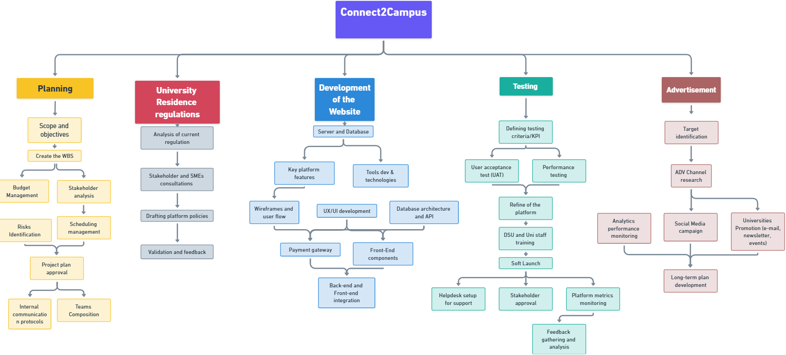
The following diagram illustrates the detailed WBS, highlighting the tasks and their relationships
within each phase:

Key Milestone

- Planning Phase Completed: The project plan, including objectives, budget, risks, and scheduling, is finalized and approved. [March 2025 , week3]
- Validation of Platform Policies: The platform policies are validated by stakeholders and SMEs, ensuring regulatory integration. [April 2025, week 2]
- Core Platform Features Ready: The core functionalities of the platform (server, database, API, UX/UI) are implemented and ready for testing. [May 2025, week 3]
- Integration with DSU Systems: The platform is integrated with DSU systems, and data flow functionalities are operational. [June 2025, week 2]
- User Acceptance Testing Completed: User acceptance testing is completed, and feedback is incorporated into the platform. [Juy 2025, week 1]
- Soft Launch Completed: The platform's soft launch is completed with DSU and stakeholder involvement. [July 2025, week 3]
- Social Media Campaign Launched:The social media campaign to promote the platform is launched. [August 2025, week 2].
- Campaign Results Analyzed: Advertisement campaign results are analyzed and integrated into a long-term plan. [September 2025, week 4]

According to the these milestone, the WBS structure the dependencies illustrated in the Gantt chart shows later in this chapter, a critical path is identified:

1.1 > 1.2 > 1.5 > 1.7 > 2.1 > 2.2 > 2.3 >2.4 > 3.1 > 3.6 > 3.9 > 3.10 > 3.12 > 4.1 > 4.2 > 4.4 > 4.4 > 4.6 > 5.3 > 5.5.

A delay in one of these activities will lead to a delay of the total duration of the project.

List of Activity

PHASE | ACTIVITY ID | NAME OF THE ACTIVITY | START | END | DURATION
PLANNING | 1.1 | Scope and objectives | 01/03/2025 | 03/03/2025 | 3
PLANNING | 1.2 | Create WBS | 04/03/2025 | 07/03/2025 | 4
PLANNING | 1.3 | Budget management | 08/03/2025 | 11/03/2025 | 4
PLANNING | 1.4 | Stakeholder analysis | 08/03/2025 | 15/03/2025 | 8
PLANNING | 1.5 | Scheduling management | 16/03/2025 | 20/03/2025 | 5
PLANNING | 1.6 | Risks identification | 17/03/2025 | 20/03/2025 | 4
PLANNING | 1.7 | Project plan approval | 21/03/2025 | 26/03/2025 | 6
PLANNING | 1.8 | Internal communication protocols | 21/03/2025 | 23/03/2025 | 3
PLANNING | 1.9 | Teams composition | 27/03/2025 | 29/03/2025 | 3
REGULATIONS | 2.1 | Analysis of current regulations | 27/03/2025 | 03/04/2025 | 8
REGULATIONS | 2.2 | Stakeholder and SMEs consultations | 04/04/2025 | 10/04/2025 | 7
REGULATIONS | 2.3 | Drafting platform policies | 11/04/2025 | 15/04/2025 | 5
REGULATIONS | 2.4 | Validation and feedback | 16/04/2025 | 21/04/2025 | 6
WEBSITE DEVELOPMENT | 3.1 | Server and database | 22/04/2025 | 29/04/2025 | 8
WEBSITE DEVELOPMENT | 3.2 | Key platform features | 30/04/2025 | 05/05/2025 | 6
WEBSITE DEVELOPMENT | 3.3 | Tool development and technologies | 30/04/2025 | 03/05/2025 | 4
WEBSITE DEVELOPMENT | 3.4 | Wireframes and user flow | 06/05/2025 | 12/05/2025 | 7
WEBSITE DEVELOPMENT | 3.5 | UX/UI development | 29/04/2025 | 12/05/2025 | 14
WEBSITE DEVELOPMENT | 3.6 | Database architecture and API | 29/04/2025 | 18/05/2025 | 20
WEBSITE DEVELOPMENT | 3.7 | Payment gateway | 19/05/2025 | 26/05/2025 | 8
WEBSITE DEVELOPMENT | 3.8 | Front-end components | 19/05/2025 | 29/05/2025 | 11
WEBSITE DEVELOPMENT | 3.9 | Back-end and front-end integration | 30/05/2025 | 08/06/2025 | 10
WEBSITE DEVELOPMENT | 3.10 | DSU system integration | 09/06/2025 | 15/06/2025 | 7
WEBSITE DEVELOPMENT | 3.11 | Security testing | 09/06/2025 | 21/06/2025 | 13
WEBSITE DEVELOPMENT | 3.12 | Data flow validation | 22/06/2025 | 28/06/2025 | 7
WEBSITE DEVELOPMENT | 4.1 | Defining testing criteria/KPI | 22/06/2025 | 26/06/2025 | 5
TESTING AND LAUNCH
TESTING AND LAUNCH | 4.2 | User acceptance test (UAT) | 27/06/2025 | 03/07/2025 | 7
TESTING AND LAUNCH | 4.3 | Performance testing for bugs identification | 27/06/2025 | 06/07/2025 | 10
TESTING AND LAUNCH | 4.4 | Refine of the platform | 07/07/2025 | 14/07/2025 | 8
TESTING AND LAUNCH | 4.5 | DSU and Uni Staff training | 17/07/2025 | 23/07/2025 | 7
TESTING AND LAUNCH | 4.6 | Soft launch | 24/07/2025 | 02/08/2025 | 10
TESTING AND LAUNCH | 4.7 | Stakeholder approval | 03/08/2025 | 07/08/2025 | 5
TESTING AND LAUNCH | 4.8 | Platform metrics monitoring | 03/08/2025 | 10/08/2025 | 8
TESTING AND LAUNCH | 4.9 | Helpdesk setup for support | 03/08/2025 | 08/08/2025 | 6
TESTING AND LAUNCH | 4.10 | Feedback gathering and analysis | 11/08/2025 | 16/08/2025 | 6
ADVERTISEMENT | 5.1 | Target identification | 03/08/2025 | 08/08/2025 | 6
ADVERTISEMENT | 5.2 | ADV Channell research | 09/08/2025 | 14/08/2025 | 6
ADVERTISEMENT | 5.3 | Social media campaign | 15/08/2025 | 31/08/2025 | 17
ADVERTISEMENT | 5.4 | Platform promotion (newsletter, events) | 15/08/2025 | 31/08/2025 | 17
ADVERTISEMENT | 5.5 | Campaign performance monitoring | 15/08/2025 | 04/09/2025 | 21
ADVERTISEMENT | 5.6 | Long-term plan development | 05/09/2025 | 08/09/2025 | 4

Gantt Chart
The Gantt Chart is a visual representation of the project schedule, showing the timeline of activities, their durations, and dependencies. It is an essential tool for tracking the progress of the project and ensuring all tasks are completed on time.

- Planning
  - Scope and objectives
  - Create the WBS
  - Budget management
  - Stakeholder analysis
  - Scheduling management
  - Risks identification
  - Project plan and approval
  - Internal communication protocols
  - Teams composition
Start: 01/03/2025
End: 29/03/2025
Total Duration: 28 days
Padding Time: 2 days
- University Residence Regulations
  - Analysis of current regulation
  - Stakeholder and SMEs consultation
  - Drafting platform policies
  - Validation and feedback
Start: 27/03/2025
End: 21/04/2025
Total Duration: 25 days
Padding Time: 3 days
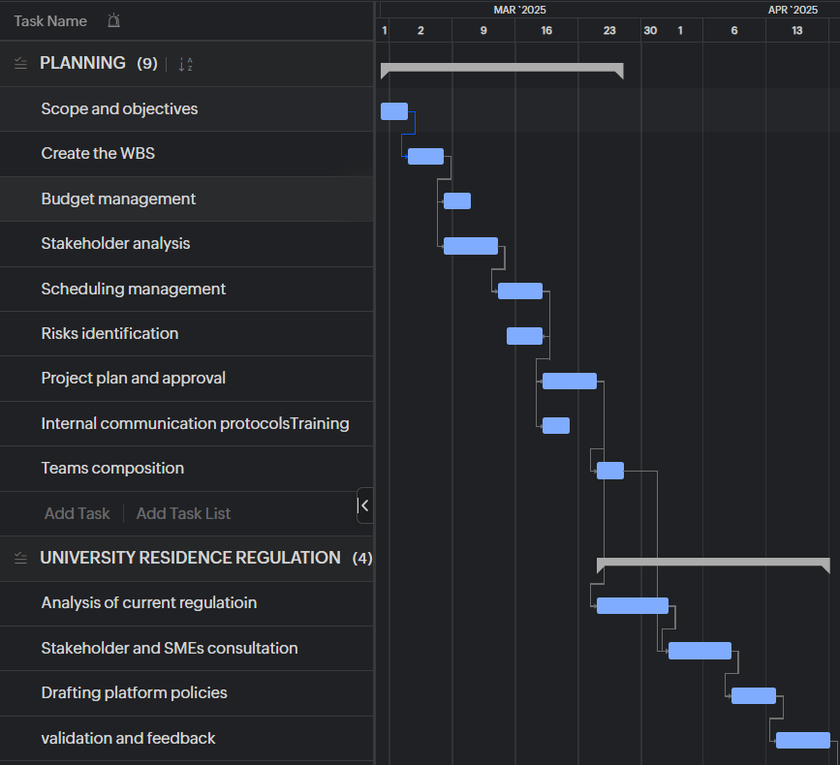
- Website Development
  - Server and database setup
  - Key platform features development
  - Tool development and technologies
  - Wireframes and user flow design
  - UX/UI development
  - Database architecture and API setup
  - Payment gateway implementation
  - Front-end components development
  - Back-end and front-end integration
  - DSU systems integration
  - Data flow validation
  - Security testing
Start: 24/04/2025
End: 28/06/2025
Total Duration: 90 days
Padding Time: 5 days
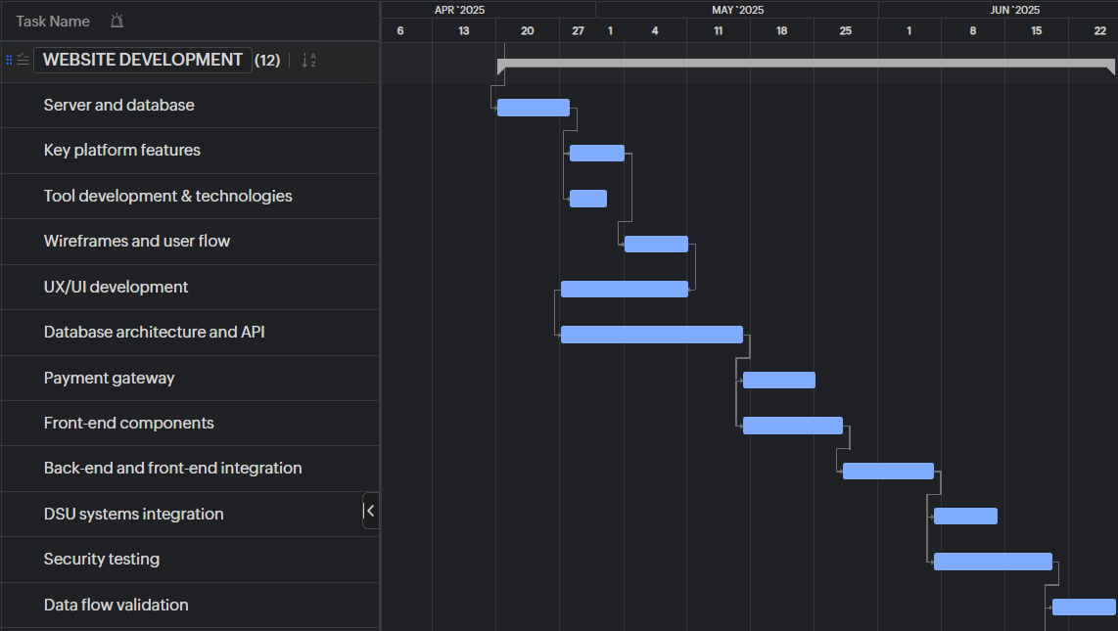
- Testing and Launch
  - Defining testing criteria/KPI
  - User acceptance testing (UAT)
  - Performance testing for bugs identification
  - Refine the platform
  - DSU and Uni staff training
  - Soft launch
  - Stakeholder approval
  - Platform metrics monitoring
  - Helpdesk setup for support
  - Feedback gathering and analysis
Start: 22/06/2025
End: 16/08/2025
Total Duration: 55 days
Padding Time: 4 days

- Advertisement
  - Target identification
  - ADV channel research
  - Social media campaign
  - Platform promotion (newsletter, events)
  - Campaign performance monitoring
  - Long-term plan development
Start: 03/08/2025
End: 11/09/2025
Total Duration: 32 days
Padding Time: 3 days
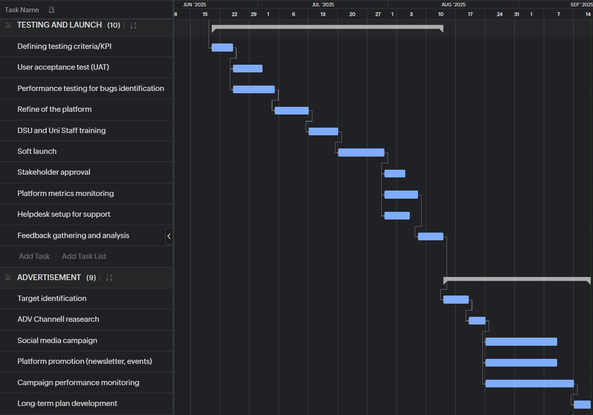

Start Date = 03/01/2025

End Date = 09/11/2025

Total Duration = 192 days

STAKEHOLDER MANAGEMENT

Good Stakeholder Management is essential to the project’s success, because it guarantees agreement amongst all stakeholders and facilitates the accomplishment of project objectives. In this section, the project’s stakeholders are listed, categorized according to their interest and influence, and a plan for involving them at every stage of the project will be introduced in this section of stakeholder management.

Stakeholder Identification
We considered the people and organizations that will either be directly impacted or involved in the platform when determining the stakeholders for this project. Given that the pilot program will take place in Italy, we focused on the local student body, Italian Universities, and local partners. We also took into account the suppliers, financiers and authorities from outside that will have an impact on the project’s startup and continuation.
The list of stakeholders identified are as follows:
- Universities in Italy
Italian universities are critical partners. They provide access to their accommodation databases and help promote the platform to students. They ensure that the platform aligns with university policies and student housing requirements.
- DSU (Diritto allo Studio Universitario)
DSU is an essential stakeholder in the pilot program, as it supports students with accommodation, financial aid, and services in Italy. DSU will help facilitate access to university accommodation databases, ensuring that the platform integrates well with the available student housing options. Their collaboration is crucial for making the platform widely accessible and aligned with student needs.
- Enrolled Students in Italian Universities
These students are the primary users of the platform. They will use the platform to book discounted university accommodation. Their feedback will be vital for refining the platform during the pilot phase.
- Project Team
The internal team responsible for the platform's development, management, and execution, including project managers, developers, marketing staff, and customer support.

- Third-party Providers
External vendors that provide services such as payment processing, hosting, and technical support. These providers are critical to ensuring that the platform runs smoothly and securely.
- Government and Regulatory Bodies in Italy
These organizations ensure that the platform complies with local laws and regulations, including student accommodation rules, data protection laws, and business operations in Italy.
- Investors/Funders
The financial backers of the project expect regular updates on the platform’s development, milestones, and financial status, particularly as the pilot program progresses.
- Marketing/Advertising Partners
Partners who will be responsible for promoting the platform to students and universities in Italy, helping to drive awareness and adoption through digital campaigns and targeted outreach.
- Private Accommodation Providers in Italy
These are providers of private accommodations such as hostels or private landlords. While not directly part of the platform’s focus initially, they may be indirectly impacted by the university accommodation offerings or might be potential partners for future expansion.
- Local Communities and Cultural Groups in Italy
Local organizations that will benefit from increased international student engagement. These groups support cultural exchange and contribute to the broader educational experience.

Stakeholder Analysis
A Power/Interest Matrix has been adapted in this project for the stakeholder analysis to classify stakeholders and assess the necessary level of engagement required with each stakeholder. This aids in determining which stakeholders demand less direct participation and which require frequent interaction.

Stakeholder | Interest (High/Low) | Power(High/ Low)
Universities in Italy | High | High
DSU | High | High
University Students | High | Low
Project Team | High | High
Third- Party Providers | Low | High
Government and Regulatory Bodies | Low | High
Investors | Low | High
Marketing/Advertising Partners | High | Low
Private Accommodation Providers | Low | Low
Local Communities | Low | Low

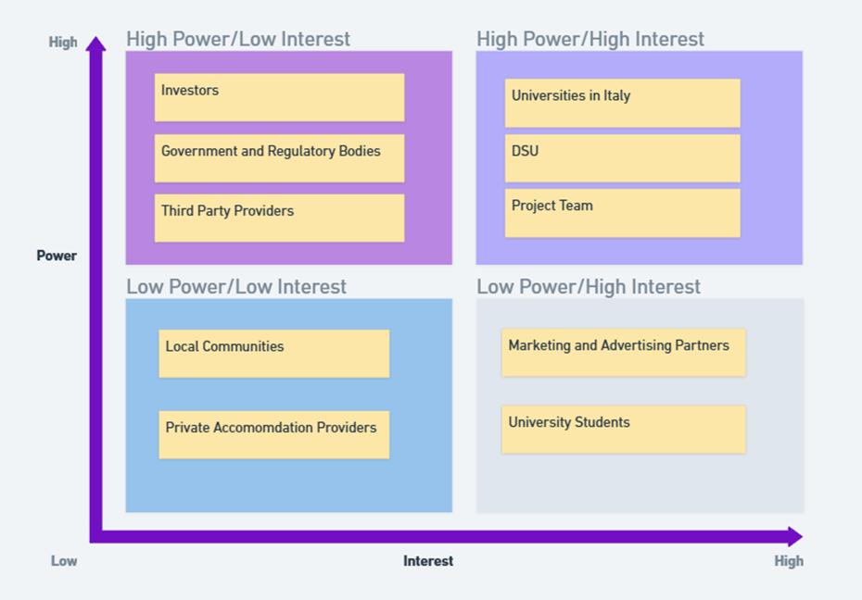
To further understand the table a Power/Interest Matrix Chart has been adapted according to the stakeholders, which can be seen below.

Each of these stakeholder groups have specific engagement requirements based on their level of interest and influence. Below are the strategies that we would use to engage with our stakeholders.
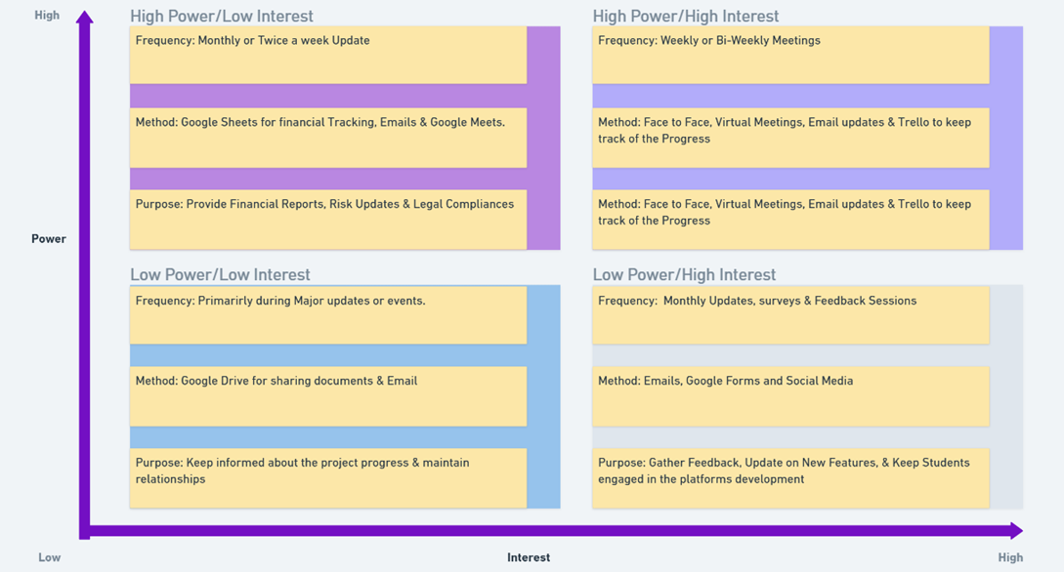

The Frequency of Contact, Method Used, and Purpose for Stakeholders are mapped onto the Power/Interest Matrix to ensure that communication efforts are aligned with the level of influence and interest each stakeholder has on the project. Stakeholders with High Power and Interest will have frequent and direct communication through methods like meetings, emails and reports to make sure that they are engaged and informed. For stakeholders with low power and low interest, less frequent communication, such as email updates and periodic surveys will suffice. This approach ensures that each stakeholder receives the appropriate level of attention and engagement based on their role and influence. Ultimately facilitating a smoother project execution and alignment with their expectations.

Tools for Stakeholder Management
To ensure efficient management of stakeholders, we will leverage specific project management tools that will help our team track progress, monitor communication, and maintain regular engagement with key stakeholders. These tools will allow us to document stakeholder interactions, set reminders for follow-ups, and share updates in a timely and organized manner. By using these tools, we aim to ensure that the stakeholders are consistently informed and that their feedback is captured and addressed as needed throughout the project’s lifecycle.

- Trello: Will be primarily used for Task Management, Visual collaboration, Tracking Stakeholder Communication and Project Progress.
- Google Meets: For Real Time communication, collaboration, and updates.
- Google Workspace: For document creation, collaboration, and storage of key communication records and reports.
- Google Drive: Especially Used for Sharing Documents and Reports on ongoing tasks.
- Google Forms: Feedback collection from students and other stakeholders.
- Smartsheet: For tracking stakeholder engagement plans and monitoring progress through Gantt charts and reports.

These are the key tools that will be used for effective stakeholder management to ensure that everyone is kept in the loop, and that all relevant information is communicated clearly and promptly. By using these tools, we will ensure seamless collaboration, track stakeholder engagement, and ensure that each stakeholder receives the appropriate level of attention.

Conflict Management
During the project, conflicts may arise between stakeholders due to differing interests, priorities, or concerns. To effectively manage these conflicts, we will employ an initiative-taking approach, which includes early identification of potential issues, open communication, and seeking mutually beneficial solutions.

Key strategies for conflict management will include:
- Open Communication: Encouraging transparent, respectful communication between all stakeholders to address concerns early and avoid misunderstandings.
- Active Listening: Ensuring that all parties feel heard, and their concerns are taken into consideration before making decisions or taking action.
- Stakeholder Prioritization: In cases where there are conflicting interests, prioritizing stakeholders based on their power and influence (as identified in the Power/Interest Matrix) will help to manage expectations and make informed decisions.
- Regular Updates and Feedback: Providing consistent updates to stakeholders will help manage expectations and reduce misunderstandings. Gathering regular feedback will also allow us to adjust our strategies as needed.
- Negotiation and Compromise: When conflicts arise, we will look for win-win solutions through negotiation, where both parties can reach a compromise that supports the overall goals of the project.
- Escalation Process: In the case of unresolved conflicts, a formal escalation process will be in place. This will involve bringing in senior project leaders or relevant decision-makers to facilitate a resolution.
- Issue Log: An Issue Log will be maintained to track conflicts, concerns, or issues raised by stakeholders. This log will serve as a record of all identified issues, ensuring they are addressed in a timely manner. Each issue will be assigned to a responsible team member for resolution, with clear deadlines and actions. This approach allows for organized tracking of conflicts and ensures that no issue is overlooked.
By actively addressing potential conflicts and focusing on clear, open dialogue, we aim to minimize disruptions and keep the project on track while maintaining strong relationships with all stakeholders.

COSTS MANAGEMENT
The purpose of this project is to create a platform that provides students with affordable and accessible options for booking discounted university accommodation. It will focus on the Italian market initially, with collaboration from universities to gain access to their room databases. The total allocated budget for the project is €180,000, with a 15% contingency (€27,000), bringing the total available budget to €207,000.

Detailed Cost Breakdown
A. Development Costs (Website and Platform)
The development of the platform is the largest cost component, as it involves creating a functional, user-friendly system for booking discounted university accommodations.
- Website and Platform Design:
  - UI/UX Design: Professional design of the website interface for both students and university administrators.
  - Wireframing and Mockups: Includes the creation of proto
  - types for the platform's interface.
  - Estimated Cost: €40,000
( UI/UX design and wireframing are crucial to ensure ease of use and accessibility for students and universities. High-quality design ensures a positive user experience, which is essential for platform adoption.)
- Website Development (Frontend and Backend):
  - Frontend Development: Implementing the designs for responsive web pages and ensuring the platform is user-friendly across all devices.
  - Backend Development: Building the database and server architecture to manage bookings, payments, and room availability.
  - Payment Gateway Integration: Integration of secure payment methods for students to book accommodations.
  - Accommodation Database Integration: Creating an API or method to integrate university room databases for real-time availability.
  - Estimated Cost: €50,000
(Rationale: Significant investment in both frontend and backend ensures a fully functional platform with high scalability and reliability.)
- Testing and Quality Assurance (QA):
  - Bug Fixing: Testing for bugs and issues on both the frontend and backend.
  - Usability Testing: Testing for user experience, ease of navigation, and feature completeness.
  - Security Testing: Ensuring data protection and payment security.
  - Estimated Cost: €10,000
(Rationale: Testing is essential for launching a stable and secure platform that users can trust and engage with.)
Total Development Cost: €100,000
B. Marketing and Promotion
Marketing efforts will focus primarily on promoting the platform to students and universities in Italy. The goal is to generate awareness and build a user base.
- Targeted Marketing Campaign (Italy):
  - Digital Marketing: Social media ads, search engine marketing (SEM), and display ads targeting students and educational institutions.
  - Content Marketing: Creating blog posts, social media content, and videos to increase visibility.
  - Influencer Marketing: Collaborations with university influencers or student organizations to promote the platform.
  - SEO and SEM Campaigns: Implementing search engine optimization and marketing strategies for organic and paid search results.
  - Estimated Cost: €25,000
(Reaching the Italian student market is key to the platform’s early success. A robust marketing campaign is crucial to generate interest and establish a strong presence.)
- Branding and Promotional Materials:
  - Designing Brand Assets: Logo, website branding, and marketing collateral.
  - Print Materials: Flyers, brochures, and posters for on-campus promotion.
  - Event Sponsorships: Costs associated with sponsoring university events, fairs, and meetups.
  - Estimated Cost: €5,000
(Rationale: Branding and promotional materials are necessary for initial outreach and engagement with students and universities.)
Total Marketing Cost: €30,000
C. Partnership Development
Building partnerships with universities is essential for gaining access to their accommodation databases. This section covers the costs associated with establishing these partnerships and collaborating with third-party service providers.
- University Engagement and Partnerships:
  - Outreach and Negotiation: Outreach to universities, meetings, and negotiations for agreements.
  - Contracting and Legal Fees: Legal support for drafting contracts and memorandums of understanding (MOUs).
  - Incentive Programs: Offering incentives for universities to participate in the platform.
  - Estimated Cost: €10,000
(Rationale: Forming partnerships with universities ensures access to their accommodation rooms, which is the backbone of the platform.)
- Third-Party Support Services:
  - Platform Maintenance Services: Costs related to ongoing technical support for the platform.
  - Customer Support Services: Outsourcing customer support, including handling inquiries and bookings.
  - Technical Support for Integration: External help for smooth integration between the platform and university accommodation databases.
  - Estimated Cost: €15,000
(Rationale: Third-party services ensure the platform runs smoothly post-launch and that technical integration with universities is supported.)
Total Partnership Development Cost: €25,000
D. Project Management and Operations
The management and operational activities ensure that the project stays on track and that the platform is sustainable after launch.
- Project Management:
  - Salaries for Project Managers: Cost for overseeing the entire project, ensuring timeliness and quality standards are met.
  - Coordination with Stakeholders: Ongoing communication with universities, development teams, and marketing teams.
  - Estimated Cost: €15,000
(Rationale: Effective project management is necessary to keep the project on schedule, manage risks, and ensure successful collaboration.)
- Operational Costs:
  - Office Supplies and Equipment: Necessary materials for the team to function, including software tools and hardware.
  - Administrative Expenses: Includes office rent, utility costs, and other administrative overheads.
  - Estimated Cost: €5,000
(Rationale: Operational costs are required to maintain a functioning team and ensure that day-to-day activities proceed smoothly.)
Total Project Management and Operations Cost: €20,000

E. Contingency Fund
- Contingency Fund:
  - Reserved for unexpected costs, risks, or unforeseen delays. This ensures the project can continue to progress even if issues arise.
  - 15% of Total Budget: €27,000

Total Budget Allocation

Category | Estimated Cost (€)
Development Costs (Website & Platform) | 100,000
Marketing and Promotion | 30,000
Partnership Development | 25,000
Project Management and Operations | 20,000
Contingency Fund | 27,000
Total | 207,000

Key Considerations

- University Partnerships: The success of the platform depends heavily on strong relationships with universities. Investment in partnership development will pay off by giving access to critical room data and promoting the platform within university communities.
- Marketing Strategy: The initial focus will be on Italy. However, subsequent phases may involve expanding marketing efforts as the platform grows. Considerations for student preferences, local trends, and university participation will help tailor the marketing message.
- Platform Security: As the platform involves payment transactions, cybersecurity and data protection should be prioritized to ensure the safety of user data.

RISKS MANAGEMENT
Risk management is a cornerstone of successful project delivery, ensuring that potential challenges are addressed proactively and opportunities are leveraged. For the Connect2Campus project, a comprehensive risk management approach is adopted to systematically identify, analyze, respond to, and monitor risks throughout the project lifecycle. This approach aims to minimize the probability and impact of negative risks while enhancing the project’s ability to meet its objectives.
Key steps include:
- Identifying Risks: Exhaustively documenting potential risks.
- Creating a Risk Breakdown Structure (RBS): Categorizing risks for clarity and focus.
- Qualitative and Quantitative Analysis: Evaluating risks based on likelihood and impact.
- Developing Risk Responses: Planning strategies in accordance with risk factors.
- Monitoring and Controlling Risks: Continuously tracking and adjusting risk
responses.

Identifying Risks
The first step involves a comprehensive identification of risks that could impact the Connect to Campus project. These risks are logged in a risk register for systematic tracking:
R1: University Reluctance & DSU: Hesitation from universities due to liability or reputational concerns.
R2: Low Student Adoption: Lack of engagement from students, potentially due to limited awareness or perceived value.
R3: Platform Functionality Issues: Delays or inefficiencies in developing a robust, scalable platform.
R4: Data Breaches: Risks of unauthorized access or cyberattacks compromising user data.
R5: Budget Overruns: Costs exceeding allocated funds due to unforeseen development or operational expenses.
R6: High Marketing Expenditure with Low Returns: Ineffective marketing strategies leading to poor engagement and low ROI.
R7: Post-Launch Technical Support Issues: Inadequate resources for addressing technical problems after deployment.
R8: Misalignment of Stakeholder Goals: Conflicting priorities or lack of engagement from key stakeholders.
R9: Unexpected Legal Costs: Potential legal fees arising from compliance challenges or disputes.
R10: Delayed Stakeholder Approvals: Slowed decision-making impacting project timelines.
R11: Resource Constraints: Insufficient staffing or tools to meet operational needs.
R12: Technological Integration:Problems integrating the platform with existing DSU or university systems.
R13: Scalability Issues: Difficulty managing a sudden increase in users (especially if the project expands rapidly).
R14: Regulatory Changes: Regulatory changes that could complicate the operation of the platform.

Risk Breakdown Structure (RBS)
To better manage risks, they are categorized into a hierarchical Risk Breakdown Structure:
1. Technical Risks
- R3: Platform functionality issues
- R4: Data breaches
- R7: Post-launch technical support issues
- R12: Technological Integration
- R13: Scalability Issues

2. Financial Risks
- R5: Budget overruns
- R6: High marketing expenditure with low returns
- R9: Unexpected legal costs
3. Stakeholder Risks
- R1: University reluctance
- R8: Misalignment of stakeholder goals
- R10: Delayed stakeholder approvals
- R14: Regulatory Changes

4. Operational Risks
- R7: Inefficient post-launch operations
- R11: Resource constraints

Qualitative and Quantitative Risk Analysis
Each risk is analyzed to determine its likelihood and impact, which helps prioritize mitigation efforts.
Likelihood Scale:
- Rare (<5%)
- Unlikely (5%-25%)
- Possible (26%-50%)
- Likely (51%-75%)
- Almost Certain (>75%)

Impact Scale:
- Insignificant (minimal effect on objectives).
- Minor (slight delays or cost increases).
- Moderate (significant delays or increased costs).
- Major (severe impact on scope, time, or cost).
- Critical (project failure or major scope compromise).
Analysed Table
Risk ID | Risk Description | Likelihood | Impact
R1 | University reluctance & DSU | Possible | Critical
R2 | Low student adoption | Likely | Critical
R3 | Platform functionality issues | Possible | Major
R4 | Data breaches | Unlikely | Moderate
R5 | Budget overruns | Possible | Moderate
R6 | High marketing expenditure with low returns | Possible | Minor
R7 | Post-launch technical support issues | Likely | Moderate
R8 | Misalignment of stakeholder goals | Likely | Critical
R9 | Unexpected legal costs | Almost Certain | Moderate
R10 | Delayed stakeholder approvals | Likely | Major
R11 | Resource constraints | Unlikely | Minor
R12 | Technological Integration | Likely | Critical
R13 | Scalability Issues | Rare | Insignificant
R14 | Regulatory Changes | Unlikely | Critical

Risk Matrix
The risk matrix provides a visual representation of the risks identified for the Connect2Campus project, categorized by their likelihood of occurrence and potential impact on the project. This tool enables the project team to prioritize risks effectively, focusing resources and mitigation strategies on the most critical areas.
Each risk is plotted within the matrix, ranging from low likelihood and low impact (green zone) to high likelihood and critical impact (red zone). By clearly visualizing the distribution of risks, this matrix serves as a practical guide for proactive risk management, ensuring that key challenges are addressed early to minimize disruptions and safeguard project success.

LIKELIHOOD | >75% |  |  | R9
LIKELIHOOD | 51%-75% |  |  | R7 | R10 | R2, R8, R12
LIKELIHOOD | 25%-50% |  | R6 | R5 | R3 | R1
LIKELIHOOD | 6%-25% |  | R11 | R4 |  | R14
LIKELIHOOD | <5% | R13
LIKELIHOOD |  | Insignificant | Minor | Moderate | Major | Critical
 | IMPACT

Risk Responses
Risk response is a critical component of project management that involves developing strategies to address identified risks and minimize their potential impact on the project's success. There are four main strategies to manage risks: Avoid, Transfer, Mitigate, and Accept.
- Avoid: Eliminate the risk by changing the conditions or circumstances that could lead to the risk.
- Transfer: Shift the risk to another party, such as through insurance or outsourcing.
- Mitigate: Reduce the likelihood or impact of the risk through preventive actions.
- Accept: Acknowledge the risk and take no action unless it occurs, typically for low-impact risks.

R1: University Reluctance & DSU
- Mitigate: Conduct stakeholder workshops to address liability concerns. Engaging universities in discussions about their concerns and demonstrating robust measures to address them builds trust and encourages collaboration.
R2: Low Student Adoption
- Mitigate: Launch targeted awareness campaigns via university channels and social media. These campaigns focus on the benefits and usability of the platform, ensuring students are informed and motivated to use the service.
R3: Platform Functionality Issues
- Mitigate: Adopt an agile development approach for iterative improvements. Agile allows the team to identify and resolve issues in smaller, manageable increments, reducing the likelihood of significant delays or failures.
R4: Data Breaches
- Transfer: Transfer the risk by working with a cybersecurity firm for secure data storage and encryption services. Obtain insurance for data breaches to transfer financial liability.
R5: Budget Overruns
- Mitigate: Conduct regular financial reviews to identify overspending early. By frequently evaluating budget performance, the team can take corrective actions before costs spiral out of control.

R6: High Marketing Expenditure with Low Returns
- Mitigate:Track marketing KPIs closely and adjust campaigns in real-time. Utilize cost-effective marketing channels and optimize based on student feedback.

R7: Post-Launch Technical Support Issues
- Mitigate: Set up a dedicated support team, provide clear user documentation, and ensure 24/7 customer service for rapid troubleshooting.
R8: Misalignment of Stakeholder Goals
- Mitigate: Maintain regular communication with stakeholders to align priorities. Frequent updates and consultations keep stakeholders engaged and aligned with the project’s objectives.
R9: Unexpected Legal Costs
- Accept: Allocate a portion of the budget for legal costs. Accept the risk, but closely monitor legal expenses and prepare for additional legal work if needed.
R10: Delayed Stakeholder Approvals
- Mitigate: Establish a structured governance framework with clear timelines and escalation procedures to minimize delays.
R11: Resource Constraints
- Accept: Accept the risk as the impact is minor. If it arises, prioritize critical tasks and adjust project timelines where possible.
R12: Technological Integration
- Mitigate: Conduct a comprehensive technology audit before starting integrations. Ensure compatibility of systems early and build in sufficient testing periods. If needed, hire an external consultant for integration assistance.
R13: Scalability Issues
- Accept: Accept the risk as it is unlikely to occur with a minor impact. Ensure scalability is tested thoroughly in the pilot phase, and develop contingency plans if it arises.
R14: Regulatory Changes
- Mitigate: Stay up to date on relevant regulatory changes and consult with legal experts to ensure compliance. If a change occurs, swiftly adjust platform processes to align with new regulations.

Monitor Risks
Continuous monitoring ensures risks are effectively managed:
- Risk Register Updates: Document new risks and track mitigation efforts.
- Regular Meetings: Conduct bi-weekly risk reviews with the project team.
- Performance Metrics: Use KPIs to evaluate the success of risk responses.
- Stakeholder Reports: Share updates with stakeholders to maintain transparency.
- Post-Launch Analysis: Review risk outcomes to inform future projects.
By implementing this robust risk management framework, the Connect2Campus project is better positioned to navigate uncertainties, maximize opportunities, and deliver its objectives successfully.

PROJECT QUALITY MANAGEMENT
Quality Management is a foundational element of the Connect2Campus project, ensuring that all project deliverables align with stakeholder expectations, adhere to established standards, and achieve the intended objectives. It encompasses both proactive measures, aimed at preventing issues, and reactive measures, which focus on identifying and addressing defects in the deliverables. This comprehensive framework ensures that the Connect2Campus platform delivers optimal value to its users while maintaining reliability, security, and usability throughout its lifecycle

Quality Objectives

Primary Goal: Deliver a platform that provides an exceptional user experience while meeting technical, functional, regulatory, and user-centered standards.
User Experience: Ensure the platform is intuitive and seamless for students and stakeholders, with easily accessible and user-friendly functionalities.
Integration: Integrate the platform seamlessly with DSU systems and university housing management platforms for smooth synchronization of:
- Room availability
- Booking confirmations
- Administrative data
Operational Reliability: Aim for the platform to maintain an uptime of at least 98%, minimizing disruptions and ensuring continuous availability for users.
User Feedback: Achieve a positive feedback rate of at least 70% during the pilot phase to demonstrate strong user satisfaction and confidence in the platform’s capabilities.

Quality Standards and Metrics
The Connect2Campus project follows strict quality standards to ensure the platform is reliable, user-friendly, and meets expectations. Technically, the platform is built for high performance, security, and scalability, providing a solid foundation for all its features. It includes advanced room search and booking tools, user-friendly dashboards, and real-time updates that work accurately and efficiently.
The project also ensures compliance with important regulations, such as GDPR for data privacy and DSU housing system rules. To enhance user experience, it follows accessibility guidelines (WCAG), supports multiple languages, and is designed to work well on all devices.

The platform's success is measured using key goals, like achieving a booking success rate of over 5%, fixing all major issues before launch, ensuring system responses are faster than one second, and earning at least 80% user satisfaction.
Quality Assurance (QA) Processes
QA in the Connect2Campus project integrates quality at every stage of development through proactive measures. Key activities include thorough reviews of project requirements to eliminate ambiguities, routine code reviews to ensure adherence to standards, and iterative testing across unit, integration, and regression levels. Compliance audits ensure the platform aligns with legal and regulatory standards, particularly for data protection and privacy, safeguarding system reliability and integrity.
Quality Control (QC) Processes
QC focuses on detecting and resolving defects to meet established quality benchmarks. Functional testing validates platform features against requirements, while performance testing ensures scalability and reliability under simulated conditions. Security testing protects user data through penetration tests and vulnerability assessments. Usability testing collects end-user feedback via surveys and pilot programs, refining the platform's design and functionality to align with user expectations.
Roles And Responsibilities
Quality Management involves several key roles, each contributing to the overall success of the project. The Quality Manager oversees the QA and QC processes, ensuring adherence to established standards and addressing any issues that arise. The development team is responsible for implementing code that meets the required quality benchmarks, while the testing team executes the planned tests, records the results, and collaborates with developers to resolve identified issues. Stakeholders, including DSU administrators and students, play a crucial role by providing feedback on the platform's usability and functionality during pilot testing.

Tools and Technologies
The project leverages a range of tools to support its Quality Management efforts. Selenium is used for automated functional testing, while JMeter assesses the platform's performance under various conditions. Google Analytics provides insights into user behavior and experience, and custom KPI dashboards monitor specific performance indicators. Jira and Bugzilla are employed for issue tracking and resolution, facilitating efficient management of bugs and enhancements.

Quality Plan
The Quality Plan provides a structured framework for managing QA and QC activities across all phases of the project. During the pre-development phase, the team conducts detailed reviews of requirements and defines the quality standards that will guide subsequent activities. The development phase involves regular testing and code reviews, ensuring that issues are identified and resolved promptly.
Before launch, the team conducts comprehensive testing, including functional, performance, and security evaluations, to verify the platform's readiness for deployment. Post-launch, the focus shifts to continuous monitoring, collecting user feedback, and implementing iterative improvements to address any issues that emerge and enhance the platform's overall quality.

Documentation
To ensure transparency and accountability, the project maintains detailed documentation of its Quality Management efforts. The Quality Management Plan serves as a comprehensive roadmap, outlining all QA and QC activities. Test plans and reports document the results of functional, performance, and security testing, while audit reports provide records of compliance checks and reviews. Feedback collected during pilot testing is compiled into user feedback reports, offering valuable insights for future refinements.
This comprehensive approach to Quality Management ensures that the Connect2Campus platform delivers a reliable, accessible, and user-friendly solution for university housing, meeting the needs of students and stakeholders alike.

COMMUNICATION MANAGEMENT
Effective communication is vital to the success of the Connect2Campus project, ensuring alignment among stakeholders, transparency in project updates, and swift resolution of potential issues. The Communication Management Plan defines the methods, tools, and strategies for information dissemination and engagement, tailored to meet the needs of diverse stakeholder groups

Communication Objectives
The primary objectives of the Communication Management Plan are:
- To ensure all stakeholders receive timely and accurate information.
- To facilitate collaboration and alignment among the project team, universities, and students.
- To promote transparency and build trust through regular updates.
- To provide a feedback mechanism for stakeholders to share their concerns and insights.

Stakeholder Communication Requirements

Stakeholder Group | Communication Needs | Frequency | Mode of Communication
Project Team | Updates on project progress, task assignments, and risk management. | Weekly | Meetings, email, Google Workspace
Universities | Information on partnership benefits, risk mitigation measures, and progress. | Bi-weekly | Reports, email, Virtual Meetings
Students | Awareness of platform features, promotions, support availability, and User Feedback. | Monthly | Social media, Google Forms
Technical Partners | Updates on development milestones, technical challenges, and requirements. | As needed | Virtual Meetings, email, technical reports
Sponsors | Project progress, financial updates, and risk management. | Bi-Monthly | Reports, presentations

Communication Tools and Channels
To ensure effective information dissemination, the following tools and channels will be utilized:
- Project Management Software: For task assignments, progress tracking, and internal team communication (Zoho, Whimsical, Excel).
- Email: For formal updates and documentation sharing.
- Social Media: To engage students and raise awareness about the platform.
- Website: As a central hub for information, updates, and FAQs.
- Reports and Presentations: For detailed updates to sponsors and university partners.
- Webinars and Workshops: To engage universities and train users on platform features.
Establishing feedback loops is critical to refining the project and addressing stakeholder concerns:
- Surveys: Regular surveys to gauge student and university satisfaction. (Google Forms)
- Helpdesk Support: Dedicated support channels for technical and operational queries.
- Feedback Forms: Embedded on the website for easy submission of suggestions or complaints.

Monitoring and Evaluation
To ensure the effectiveness of the Communication Management Plan, regular monitoring and evaluation will be conducted:
- Communication Audits: Periodic reviews of communication effectiveness.
- Feedback Analysis: Reviewing survey results and feedback forms.
- Stakeholder Satisfaction: Measuring trust and engagement levels through direct feedback and participation metrics.
By implementing a structured Communication Management Plan, the Connect2Campus project aims to foster collaboration, transparency, and engagement, ensuring that all stakeholders remain informed and invested in the project’s success.

HUMAN RESOURCES MANAGEMENT
The Human Resource Management Plan defines the approach to managing human resources throughout the project. This includes internal team members, external resources (e.g., outsourced roles), and the strategy for ensuring that the project has the necessary skills and expertise at each phase. The plan outlines the roles and responsibilities of all team members, the recruitment strategy, training needs, and the management of external resources, including legal advisors, to ensure the project is compliant with regulations and legally sound.

Project Team Structure
This project follows a functional matrix structure, where internal team members report to the Project Manager for project-specific tasks and their functional managers for departmental responsibilities. External resources, such as specialized developers and legal advisors, will also contribute to the project’s success under the guidance of the internal team.
Internal Team Members and Roles

Name | Age | Level of Education | Role | Responsibility
Francesco Biondi | 28 | Master in Engineering Management | Project Manager, Scope and Scheduling Manager | Managing project tasks, organizing meetings with agenda items, ensures timely project execution through activity coordination, and ensuring project goals are met.
Yasheenraj Shanmugam | 22 | Master in Engineering Management | Stakeholder & Cost Manager. | Estimating the budget, managing supplier relationships, and controlling costs during the project’s execution.
Marzia  Noori | 24 | Master in  International  Accounting & Management | Quality and Human Resources Manager | Oversees project quality, communication and internal coordination to ensure smooth execution of activities and promotes the platform.
David  Hayes | 23 | Master in  International  Accounting & Management | Risk & Communication Manager | The Risk and Communication Manager identifies and mitigates potential risks while ensuring clear and timely information flow among stakeholders to keep the project on track.

External Resource Management
Certain roles require specialized expertise, and these will be outsourced to ensure the project has the necessary skills for platform development, security, marketing, and legal compliance. These external resources will work in tandem with the internal team to ensure the project's success.

Name | Role | Responsibility | Duration  (Contract Type) | Reason for Outsourcing
External Developer(s) | Web Development (Front-End/Back-End) | Develop the student accommodation booking platform, ensuring the system is user-friendly, scalable, and secure. | 7 months (Contract) | Required specialized technical skills for web development.
External Cybersecurity Expert | Security Consultant | Conduct security audits, implement encryption protocols, and ensure the platform is secure against potential data breaches. | 3 months (Contract) | Expertise required to handle platform security and data protection.
External Marketing Consultant | Marketing Specialist | Design and implement marketing strategies to engage students in Italy, analyze trends, and optimize ad spend to drive platform adoption. | 3 months (Contract) | Expertise needed for marketing and student engagement strategies.
External Legal Advisor | Legal Consultant | Provide legal guidance on university partnerships, student data protection, GDPR compliance, contracts, and potential legal disputes. | 6 months (Contract) | Expertise in data privacy laws, contracts, and risk management.

Internal Team for Platform Development
Name | Role | Responsibility | Duration/Contract Type | Reason for Internal Hiring
Platform Development Manager | Full-Time Platform Development Lead | Oversee platform development, coordinate between internal and external developers, and ensure the project meets technical specifications. | Full-Time (Permanent) | Key role to manage both external contractors and internal processes.

Human Resources Management Strategy
Recruitment and Staffing
- Internal Roles: All internal team members are recruited based on their specialized skills and experience. A Platform Development Manager will be recruited to oversee the technical aspects of the platform’s development.
- External Roles: Specialized roles such as Web Developers, a Cybersecurity Expert, a Marketing Consultant, and a Legal Advisor will be outsourced. These roles are critical to the successful development, security, marketing, and legal compliance of the platform during the pilot phase.
Training and Development
To ensure the team is well-prepared to meet the project’s goals, the following training strategies will be implemented:
- Technical Training: The Platform Development Manager will receive training on platform technologies, and external developers will be onboarded with project-specific technical requirements.
- Risk and Communication Training: Internal team members will receive training on communication tools, risk management practices, and collaboration techniques.
- Marketing Training: External and internal team members will receive training on engaging the Italian student market and digital marketing strategies.
- Legal Compliance Training: The project team will undergo briefings on GDPR, data privacy, and contractual obligations to ensure alignment with legal requirements.

Performance Management
To ensure continuous improvement and alignment with project goals, the following performance management practices will be implemented:
- Self-Assessments and Peer Reviews: Team members will complete self-assessments and provide feedback on colleagues’ contributions.
- Regular Check-Ins: The Project Manager will conduct one-on-one meetings with team members to provide guidance, support, and feedback.
- Performance Metrics: Team performance will be tracked based on task completion, adherence to deadlines, and collaboration efforts.

CONCLUSIONS
The Connect2Campus project represents a significant step towards addressing the challenges faced by university students in Italy when seeking accessible and affordable housing. By leveraging university-managed accommodations, the platform not only alleviates financial burdens, but also fosters a vibrant and inclusive academic community.
Through the integration of cutting-edge technology and stakeholder collaboration, the platform offers an innovative, user-friendly solution for real-time room booking, advanced search filters, and seamless synchronization with DSU systems. This initiative aims to optimize the utilization of vacant university residences, ensuring these resources are fully utilized for both long-term stays and short-term academic travel.
The project plan covers all critical aspects, including a robust schedule, risk mitigation strategies, stakeholder engagement, quality assurance, and an effective communication framework. These elements are pivotal to achieving the desired objectives within the set timeline and budget.
Moving forward, the pilot program will be essential in validating the platform's effectiveness. Feedback collected during this phase will inform refinements and improvements to enhance user experience and operational efficiency. The planned marketing campaigns will ensure widespread awareness and adoption, while collaboration with key stakeholders will lay the foundation for long-term growth and scalability.
In conclusion, Connect2Campus aspires to be more than a housing solution; it aims to redefine the student living experience by creating opportunities for connection, cultural exchange, and community building. With a clear vision, a well-thought-out strategy, and the commitment of all involved, the project is poised to make a meaningful impact on the lives of students across Italy, and potentially beyond.

